# A black background with white dots Description automatically generatedFYP Report

## **VOYAIGE**

## A yellow bus on a mountain Description automatically generated(Development)

**Group members:**

Hamza Rauf 21i-0604

Shamail Aamir Khan 21i-1772

Eman Furrukh 21i-1726

**Supervisor:**

Mr. Bilal Khalid Dar

**Co-Supervisor:**

Ms. Zoya Mahboob

Table of Contents

1 Introduction 5

1.1 Problem Statement 5

1.2 Problem Solution 5

1.3 Scope 6

1.4 Modules 6

1.5 User Classes and Characteristics 7

2 Project Requirements 8

2.1 Use-case 8

2.2 Functional Requirements 9

2.3 Non-Functional Requirements 10

2.4 Domain Model 10

3 System Overview 16

3.1 Architecture Design 17

3.2 Design Models 19

3.2.1 Class Diagram 19

3.2.2 Sequence Diagram 20

3.3 Data Design 21

References 22

# List of Figures

Figure 1: Use Case Diagram………………………………………………………………………..…….pg 8

Figure 2: Homepage…………………………………………………………………………………..…….pg 11

Figure 3: Chatbot…………….………………………………………………………………………..…….pg 12

Figure 4: Form-based……….………………………………………………………………………..…….pg 12

Figure 5: Pre-planned Trip….………………………………………………………………………..……pg 13

Figure 6: User Customization….…………………………………………………………………..…….pg 14

Figure 7: Domain Model for Chatbot……………………………………………………………..……pg 15

Figure 8: Architecture Diagram..……….…………………………………………………………..…..pg 17

Figure 9: Process Flow……………………………………………………………………………………..pg 18

Figure 10:Class Diagram……….………….…………………………………………………………..….pg 19

Figure 11: Sequence Diagram……………..…………………………………………………………….pg 20

Figure 12: Entity Relationship Diagram..………………………………………………………….....pg 21

# List of Tables

Table 1: User Classes and Characteristics…………………………………………………..……pg 7

# Chapter 1

# Introduction

## 1.1 Problem Statement

The sheer number of choices that must be made, from selecting locations to making reservations for housing, transportation, and activities, makes trip planning a complicated and involved process. Online users feel overwhelmed by the abundant options and information, leading to choice fatigue. The overwhelming choice and complexity of the travel purchasing process caused 91% of mobile customers to abandon their transactions. [1] Managing vacation plans, financial constraints, and personal preferences requires negotiation and compromise. The lack of integrated instruments for monitoring spending creates an extra challenge for effective budget management. There are numerous disjointed tools, which raises the possibility of mistakes and inefficiency.

Nowadays, many travelers plan, book, and coordinate their trip arrangements using apps and websites. According to reports more than 95% of travelers today use digital resources for their travel journeys. [2] To obtain useful information for planning their vacation, travelers depend more on user-generated reviews, influencer content, and recommendations from other travelers on social media platforms. These services provide inspiring travel options along with community-driven opinions and up-to-date information. By simplifying the planning process, efficient integration of various digital tools can enhance travel experiences for individuals and groups.

## 1.2 Problem Solution

In an era where planning a vacation may feel like navigating a maze of choices and unknowns, Voyaige stands out as a source of clarity for tourists traveling in Pakistan by addressing the numerous challenges associated with trip planning. It redefines personalization with the help of artificial intelligence (AI) and machine learning (ML), Voyaige ensures that users have a personalized daily schedule for their journey by using chatbots and recommendations based on user-filled forms. Voyaige provides consumers with comprehensive budget management tools that offer multiple recommendations. Although the user can generate a whole trip using AI, they also have the option to customize their trip, which includes booking all the transportation and lodging options.

For users who may not have a specific destination, Voyaige offers pre-planned trips that allow customers to discover new possibilities and places. Voyaige offers tailored suggestions depending on user interests, prior travel experiences, and user reviews, as opposed to the general suggestions made on conventional travel websites. Websites offer user-generated content with insightful information that enhances the services and recommendations offered, enabling future travelers to make informed choices. Through Voyaige, users experience seamless travel planning and booking. Users no longer need to switch between numerous websites and apps.

## 1.3 Scope

The user will be welcomed onto the home page of our website where they’ll have three options in deciding how to plan their trip:

Firstly, they’ll have the option of chatting with our very own Chat-Bot Milo. They can enter any prompt, and Milo will help them plan an itinerary. They can type in “Plan a trip to the Northern Areas from Islamabad for 5 days”, that’ll get Milo to plan out a full itinerary from Day 1 to Day 5, planning where to go, what to visit, where you can stay, and the food they can enjoy there. For any customization the user wants to add, they can write/speak to Milo “Change Day 3 to fit into the budget of Rs10,000/-” and it'll update their itinerary.

Secondly, users can fill out a form answering basic traveling preferences like where their starting point is, where their destination will be, their budget, and the number of travelers they have. We will use AI to delve into the users’ choices and design the perfect itinerary based on what they’ve filled in the form. Users can still edit or update the itinerary to their satisfaction.

Thirdly, users can manually customize their entire trip. They can enter their starting point, destination point, duration point, and the number of travelers with them. They press the forward arrow button and will be presented with a page to help them fill in their itinerary along with the choice of hotels, transportation, and Airbnb for the entirety of the trip.

Besides the options of choosing how to plan their trip, users have the option of viewing tourist attractions with Panoramas (which provide a 360º view). They can also get recommended pre-planned trips based on their previous trips. They can book their transport (i.e., rent a car, book a bus, book a train), hotel, and Airbnb with the help of our website. Moreover, our website can recommend restaurants to visit based on users’ ratings and reviews. They can also take part in the challenges set by our website to earn points which can get them discounts for future trips!

## 1.4 Modules

We have several modules for our project:

* + 1. Chatbot (Milo)

This module features an interactive chat interface powered by NLP and through Sentiment Analysis. Users can interact with Milo to help plan an itinerary and update it according to their satisfaction.

* + 1. AI Trip Planning Form

This module allows users to fill in a small form which helps make a perfect itinerary for them based on the answers filled in the form i.e., your starting point, destination, budget, and number of travelers.

* + 1. User Customized Trip Planning

This module allows you to customize your trip. You pick out the starting point, destination, duration, and number of travelers. After that, you pick out what you want to do each day and pick out your transportation, hotel, or Airbnb to your liking directly from our website.

* + 1. Tourist Attractions Panoramas

This module offers 360º panoramic views of various tourist attractions across the country. Users can interact with and navigate the images to explore numerous locations.

* + 1. Recommendation Systems

This module provides personalized trip recommendations based on your previous trips. It also suggests restaurants to visit based on users’ reviews and ratings.

1.4.6 Booking Systems

This module allows users to book transportation (buses, cars, trains), hotels, or Airbnb’s. When customizing their trip, the User can edit each specific Day in the itinerary to add/update a booking for transport or accommodation.

1.4.7 Payment Options

This module provides users with multiple payment options, including online payment through Bank Transfer (Credit/Debit Cards) or EasyPaisa, and the ability to print an invoice for payment in cash or by cheque through their respective bank.

* + 1. Challenges and Incentives

This module presents users with multiple challenges that they can take part in to earn points. Based on these points, they can redeem them to get vouchers which they can use to earn discounts on their next trip. Hence, this allows us to track user participation and manage the reward system.

## 1.5 User Classes and Characteristics

|  |  |
| --- | --- |
| User Class | Description |
| Traveler | Is the primary user of Voyaige. They can choose how they want to plan their trip i.e., if they want to plan it manually, if they want to use AI or if they want a trip to be readily available to them. |

**Table 1: User Classes and Characteristics**

# Chapter 2

# Project Requirements

## 2.1 Use-case

The figure (Figure 1) below shows the use case diagram. It has 2 actors i.e., The User and the Admin. Both of which can login and signup. The user can plan a trip through Chatbot, Form-based trip planning, Preplanned trips, and through their own customization. The user can view their itinerary at any time. Additionally, they can view panoramas and take part in challenges to receive discounts at payment time. The admin can manage user profiles and maintain the overall recommendation systems.

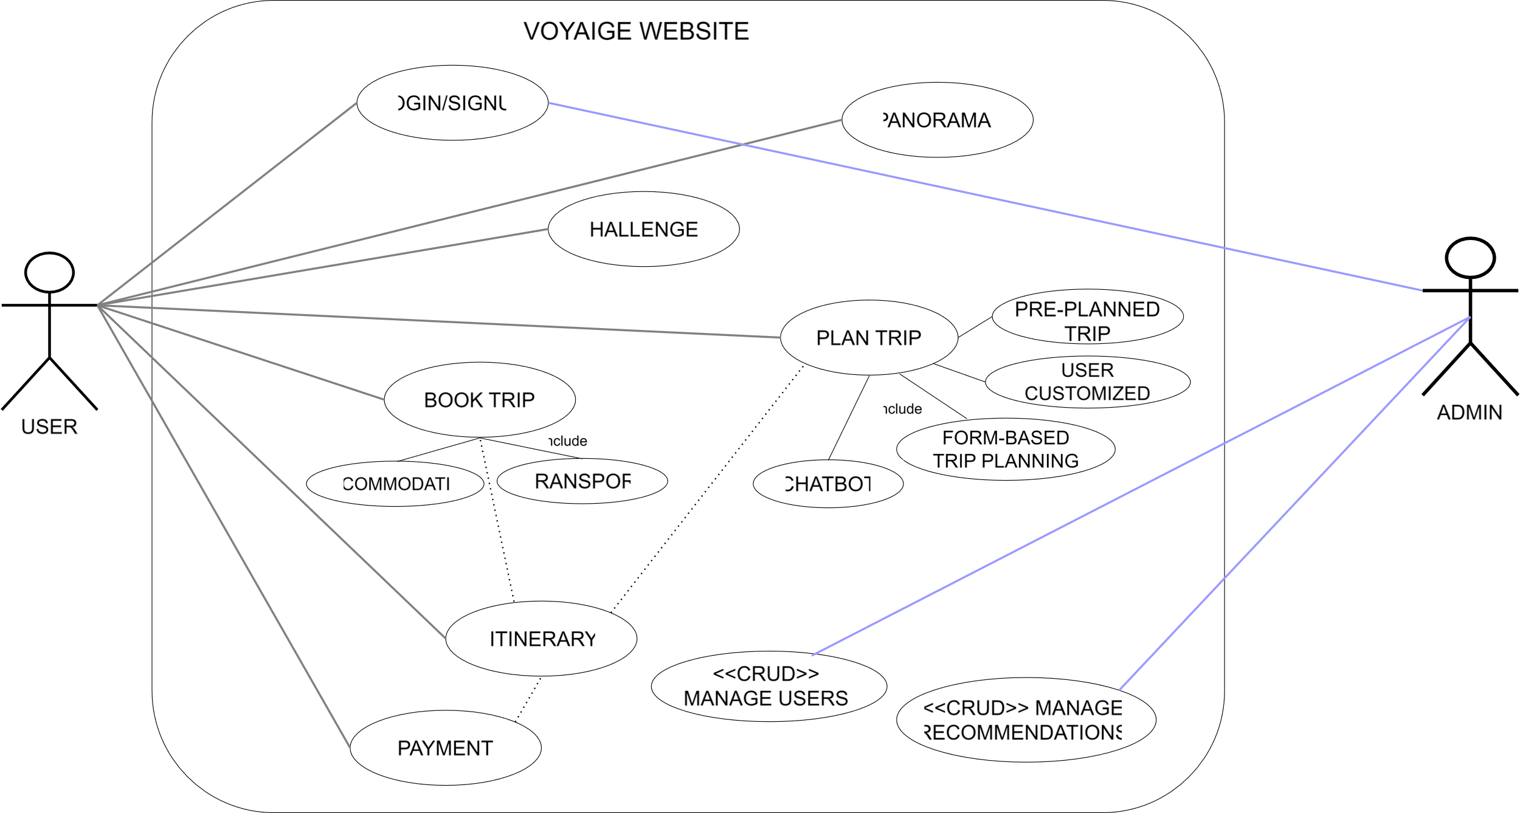

**Figure 1: Use Case Diagram**

## 2.2 Functional Requirements

Functional requirements:

1. ( Module ) Chatbot

* The user can communicate with Milo and customize the trip according to their satisfaction.
* The user can provide vocal commands, which speech-to-text recognition converts to text.
* The system allows users to make changes in the trip as they’re being generated.

1. ( Module ) AI Trip Planning Form

* The user is provided with a form to fill out to help AI understand the users’ preferences.
* The form takes information about the user required by AI to plan a perfect trip.

1. (Module ) User Customized Trip Planning

* Users can customize their trip by selecting what to do each day.
* The user can select their transportation and lodging from the list provided.
* While choosing this, the user is provided with the top recommendations for transport and lodging according to AI that best suits their budget.

1. ( Module ) Tourist Attractions Panoramas

* The system provides a better understanding to the users of the tourist attractions in the city.
* Users can interact with and navigate the images to explore various locations.
* The panorama helps users understand and navigate to explore the tourist attraction location.

1. ( Module ) Recommendation Systems

* The system provides the user with a pre-planned trip based on the previous trip explored or completed by the user.
* The user is also provided with other user reviews and ratings on the trip to help them understand their experience and decide to pursue this trip.
* The pre-planned trip provides accommodation and the best hotels, restaurants, and activities.
* The budget needed for the trip is also provided by the pre-planned trip; if the user is interested, they can pay now, and AI will make all the necessary reservations to make the journey enjoyable.

1. ( Module ) Booking Systems

* Users can book transportation and hotels directly from the website without navigating to another website.
* Booking can be done based on user choice.

1. ( Module) Payment Options

* The User has multiple payment options, including online payment, bank transfer (credit or debit cards), or EasyPaisa.
* The User will also be provided with the ability to print an invoice for payment in cash or by cheque through their respective bank.

1. (Module ) Challenges and Incentives

* The system provides challenges to complete to earn discounts on future trips.
* The system will keep track of the user's involvement and interactions in the challenges to award them points.
* Points that the user redeems are added when purchasing a trip package.

## 2.3 Non-Functional Requirements

The Non-Functional Requirements for Voyaige will be the following:

* + 1. Usability Requirements

USE-1: The system shall be accessed on Google Chrome.

* + 1. Performance Requirements

PER-1: The system shall have a 5-second response time for user interactions.

* + 1. Organizational Requirements

ORG-1: The system shall be coded using Python and MERN

## 2.4 Domain Model

#### Prototyping UI/UX

Before the implementation of this project, we developed a prototype using Figma to help form a guide for us to follow when developing our website. Here are a few of our main pages:

* Home Page

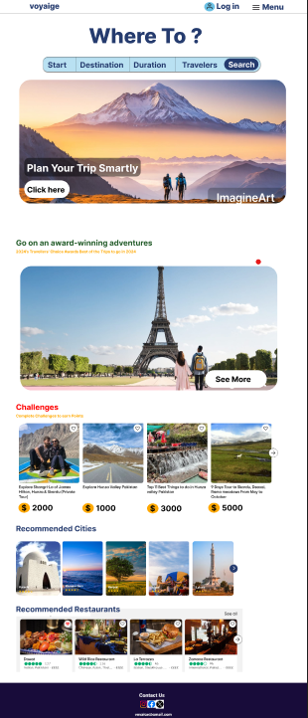

**Figure 2: Home Page**

* Chatbot Page

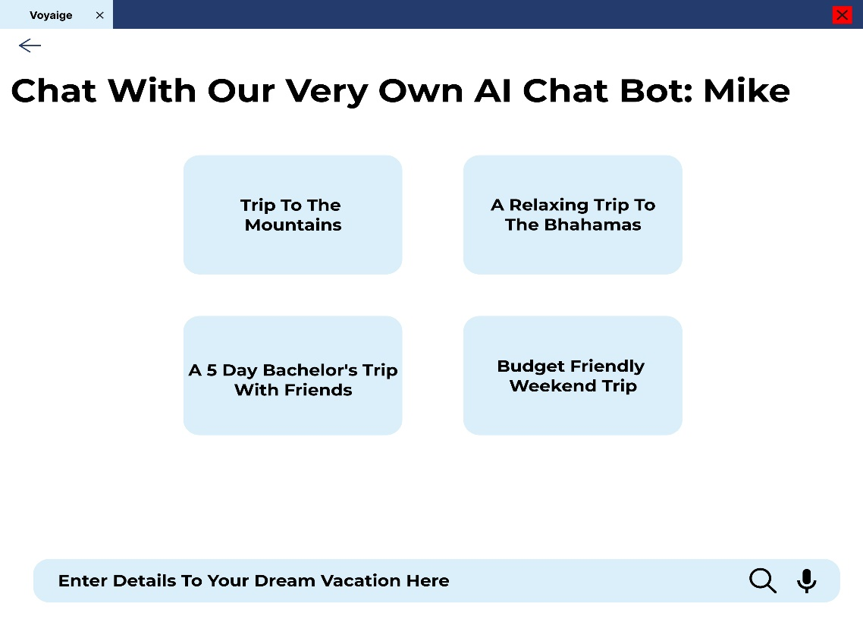

**Figure 3: Chatbot**

* Form-based Recommendations Page

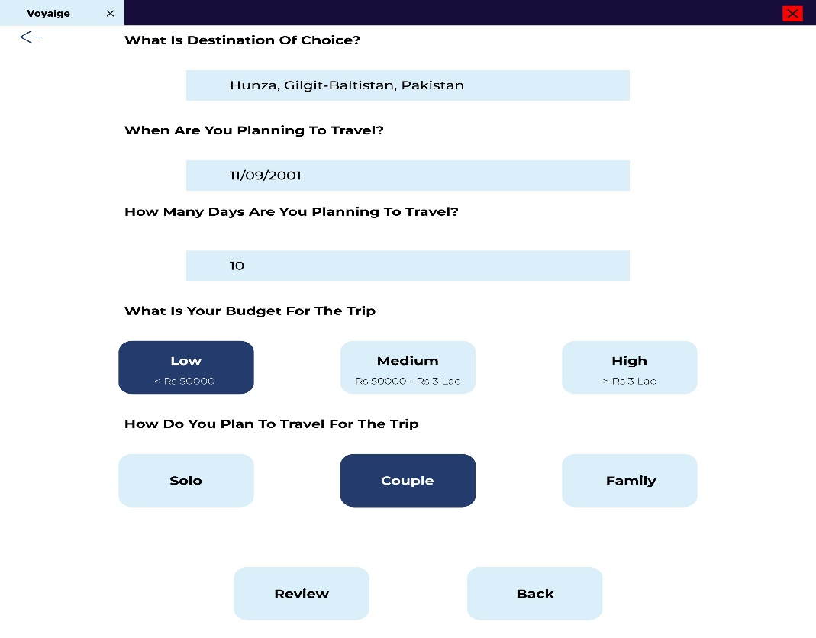

**Figure 4: Form-based Recommendation System**

* Pre-Planned Trip Page

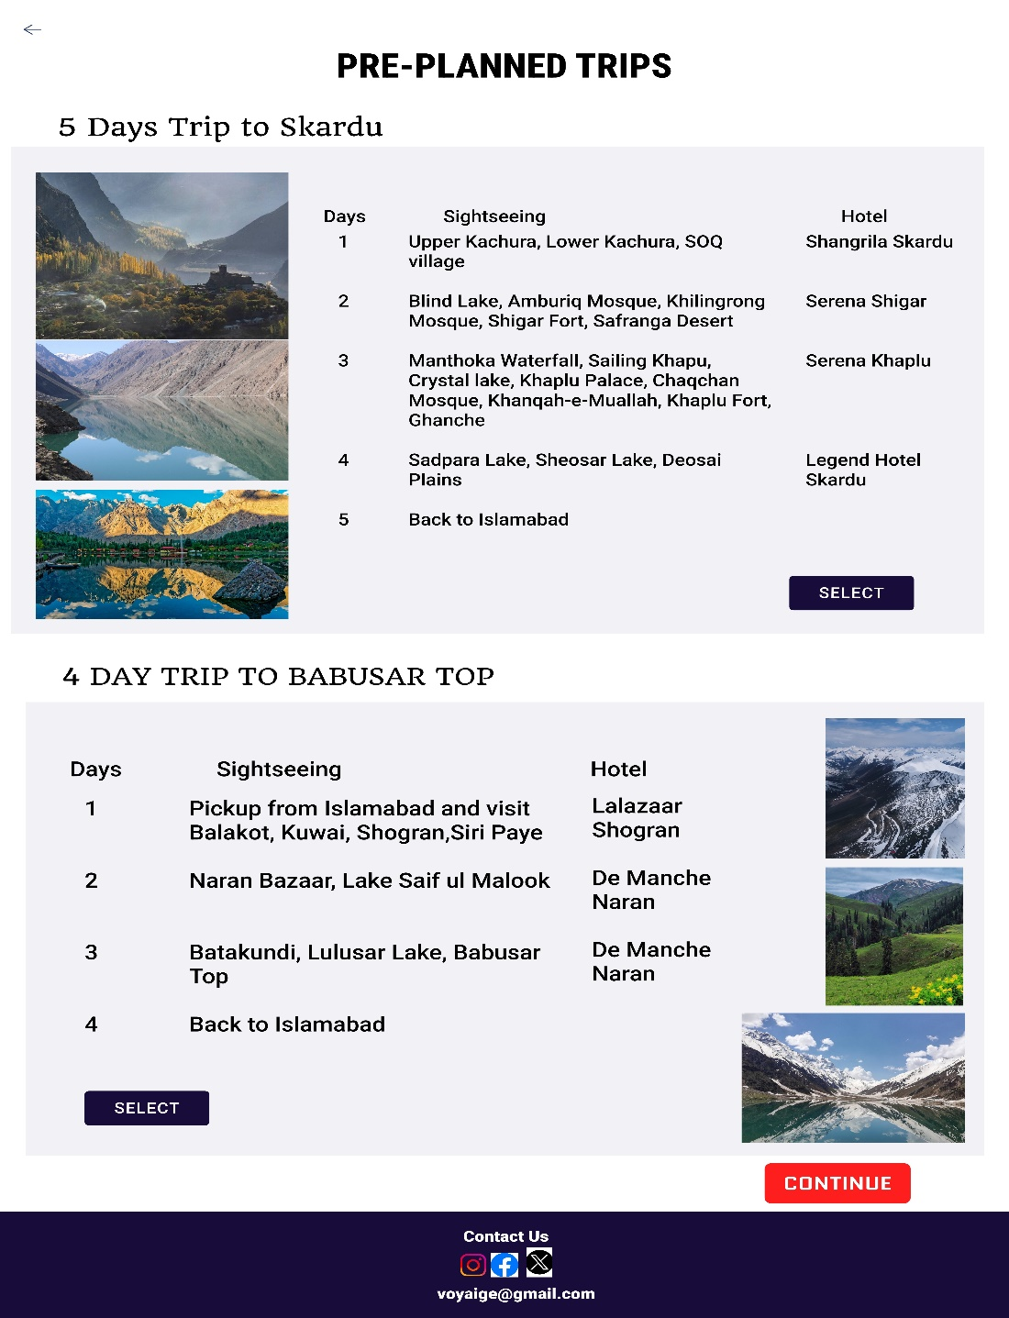

**Figure 5: Pre-planned Trip**

* User Customization Page

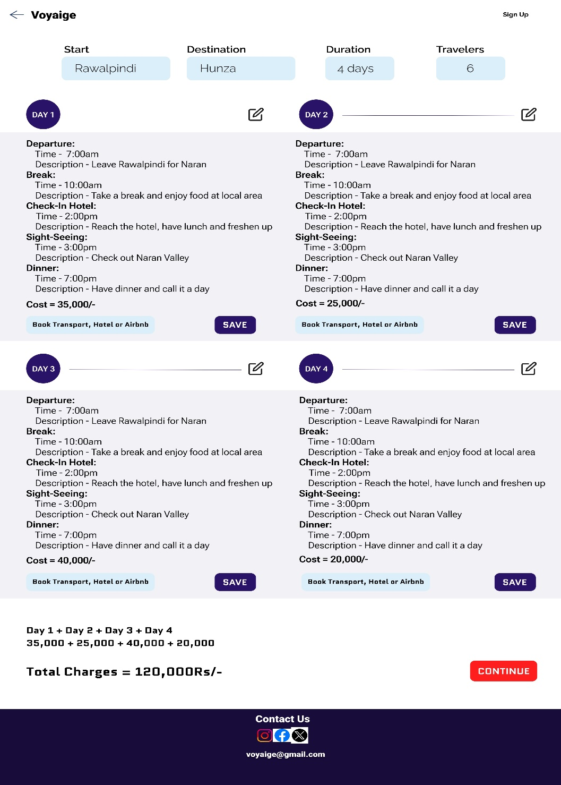

**Figure 6: User Customization**

#### 2.4.2 Chatbot

The following is how we’ve approached the implementation of the chatbot. Using different web sites to scrape transportation and accommodation related data, along with English words data which can enable the chatbot to converse with us in English and be able to provide accurate transport and accommodation options. Moreover, we’ve cleaned the data, embedded it by dividing it into chunks and then applied a pre-existing Machine Learning model on it. We’ve also implemented Lang chain framework which helps maintain context and connects the language model we’ve used with the multiple data sources we’ve collected.

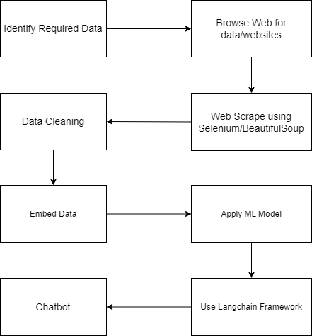

**Figure 7: Domain Model for Chatbot**

# Chapter 3

# System Overview

Voyaige is an AI-powered travel platform that simplifies personalized trip planning, especially for travelers in Pakistan. It offers AI-driven chat assistance, form-based recommendations, and manual itinerary customization. Users can book transportation, lodging, explore destinations with 360º panoramas, and earn rewards by completing challenges.

Voyaige addresses the lack of comprehensive travel planning tools for Pakistan. While platforms like TripAdvisor and Expedia offer limited customization and data for local destinations, Voyaige focuses on domestic travelers, providing detailed itineraries for popular and lesser-known locations.

**Core Features:**

Core features include our AI Chatbot (Milo) which generates itineraries based on user prompts using ML and NLP. Next, we have our Form-based Recommendation System which allows users to fill in a survey asking multiple questions related to interests or destination points in order to create an itinerary on the basis of the users’ answers. With that, we all have a Pre-planned Trip option for users who don’t want to deal with planning or booking trips. Then, we also have User Customization which allows users to manually plan their trip and book their transport/accommodation according to their preference. Voyaige also offers users to view popular tourist spots using our 360 Panoramas. Lastly, we have an incentive for users through our daily Challenges, which upon completion allows users to earn points which can be redeemed to get discounts on their trips.

**Technology:**

For the front end, we’re using React.js. For the back end, Node.js and Express.js will be used to manage different API requests. We’ll be using MongoDB to help store data. To develop our chatbot and recommendation systems, we’ll be using Python.

## 3.1 Architecture Design

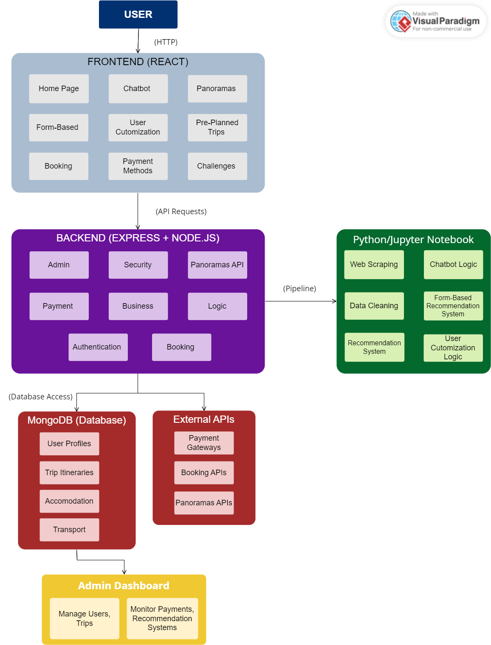

**Figure 8: Architecture Diagram**

The diagram above represents the overall structure of Voyaige. The system includes:

1. **Frontend (React)**: The user interacts with the frontend interface, which includes the core modules mentioned above. These modules handle user requests and communicate with the backend.
2. **Backend (Express + Node.js)**: The backend handles operations like user authentication, payment processing, and interactions with APIs. It includes the admin panel for managing security, panoramas API, and other services like booking and logic handling.
3. **Python/Jupyter Notebook**: This part is responsible for backend processes such as web scraping, data cleaning, and the logic for the chatbot, and the recommendation systems. The output from these processes is sent to the backend to further enhance user experience.
4. **MongoDB (Database)**: The database stores user profiles, trip itineraries, accommodation details, and transport information. The backend interacts with MongoDB to retrieve and store this data.
5. **External APIs**: External APIs handle integration with payment gateways, booking services, and panorama services. The backend accesses these to extend functionality beyond what the platform handles directly.
6. **Admin Dashboard**: This dashboard allows administrators to manage users and trips, and monitor payments, recommendation systems, and other backend activities, ensuring smooth system operations.

## Process Flow:

**Figure 9: Process Flow**

## 3.2 Design Models

### 3.2.1 Class Diagram

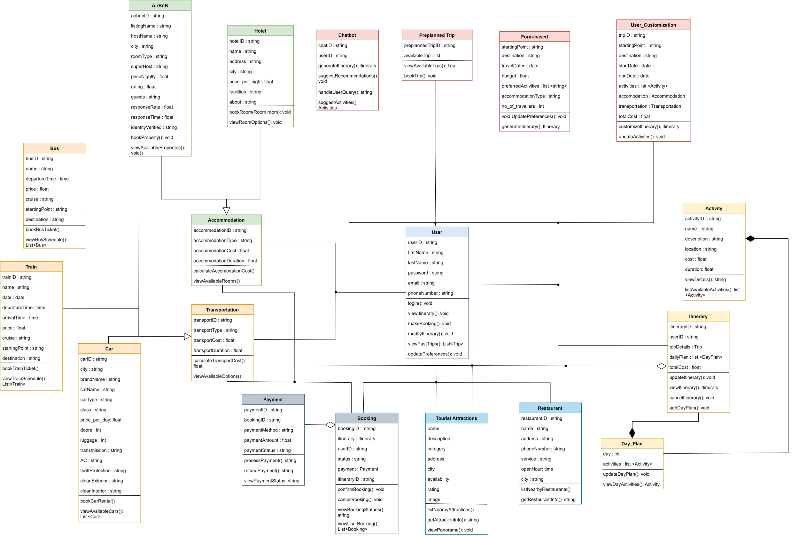

**Figure 10: Class Diagram**

### 3.2.2 Sequence Diagram

The following figure (Figure 5) shows an example scenario that could take place. The user enters the website and views all the ways they can choose to plan their trip. They then select a method and fill in details which are then processed by our code which applies ML models on it which helps prompt an itinerary to the user. The user can then view and edit this itinerary. Once it’s to the users liking, they can confirm and start booking the request. The External APIs are then used to help book transport and accommodation. Once that’s done, the booking gets saved in the database along with the itinerary. Finally, the user is asked to make payment and is asked yet again to engage with payment gateways. Upon confirmation of payment, the user is displayed a successful transaction message.

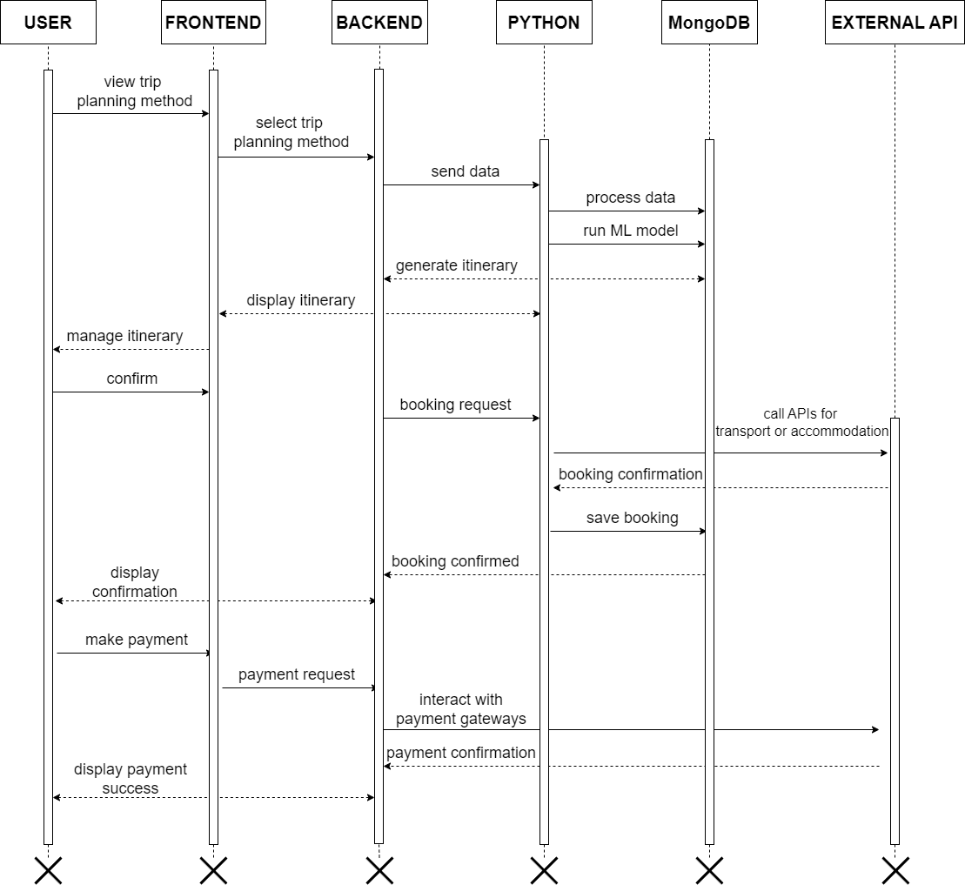

**Figure 11: Sequence Diagram**

## 3.3 Data Design

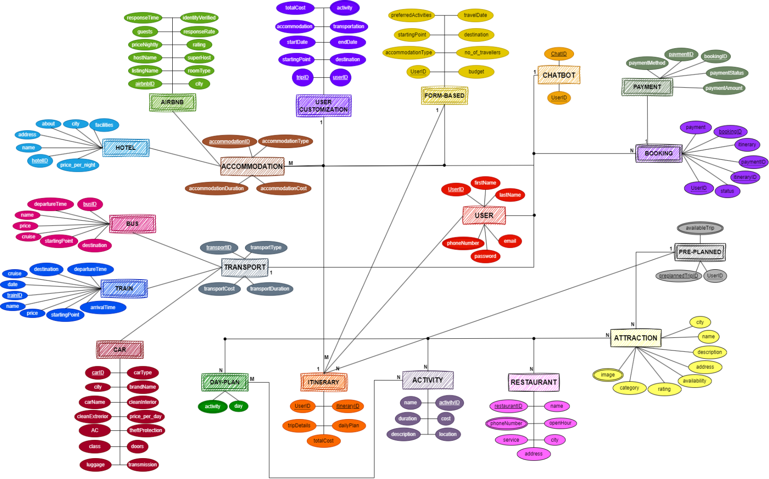

**Figure 12: Entity-Relationship Diagram**

This is an entity-relationship diagram (ERD) depicting a travel booking system. It includes key entities such as User, Accommodation, Transport, Booking, and Itinerary. The User entity connects to various modules like Customization, Form-Based trip planning, and Chatbot, which handle personalized trips and user inputs. Entities like Airbnb and Hotel under Accommodation, while Bus, Train, and Car belong to Transport. Bookings link with payment options, while pre-planned and custom trips are managed under Itinerary, which includes detailed day plans and associated activities, restaurants, and attractions.

# References

[1] BCG (2014). "Travel Goes Mobile”, 2014 Article.

Link: <https://www.bcg.com/publications/2014/transportation-tourism-technology-digital-travel-goes-mobile>

[2] TravelPerk (2024). “60+ online travel booking statistics & trends", 2024 Article

Link: <https://www.travelperk.com/blog/online-travel-booking-statistics/>